Everyday Spaces and the Experience of Social Injustice

Student name
Course: SJCJ 101
Instructor
Institution
Date

Everyday Spaces and the Experience of Social Injustice
Introduction
Social justice is not just about the absence of direct discrimination, it's about the equitable allocation of resources, opportunities, safety, recognition and social belonging. Inequality is frequently explained by forms of disadvantage that are easily visible, but also manifested in the ordinary environments and experiences that influence social participation. Where people live, move and interact in society tells more of a story of social organisation, power and exclusion. The housing environment, access to public resources, and social participation opportunities are shaped by the processes of economy and institutions, and not just individual situations. Studies of housing insecurity highlight that inequality in housing access is linked to broader social and economic structures that shape who is secure and vulnerable (DeLuca & Rosen, 2022). Likewise, racialized homelessness patterns reveal how past and present patterns of inequality shape homelessness exposure (Fowle, 2022).
This photographic essay employs visual analysis, exploring the potential of ordinary environments to expose invisible aspects of social inequality. Photographs are not merely pictorial only but represent also sociological evidence and can be used to explore the interactions between people, places and social structures. Neutral spaces such as buildings, streets, parks, housing areas, and public spaces are formed through policies, systems, and social relationships which affect access and belonging. Public spaces help to foster social cohesion, by enabling interaction, participation and a sense of connectedness, but can at the same time resonate with unequal experiences of inclusion and exclusion (Aelbrecht & Stevens, 2019). This essay addresses environmental inequality, homelessness, housing insecurity, urban displacement, public belonging, and unequal experiences of safety through six original photographs.
PHOTO 1 SECTION.
Environmental Access and Unequal Well-being

The image shows a person near a body of water at sunset, surrounded by a forest-like landscape with open areas and greenery, suggesting a peaceful and scenic location. The individual's location helps expose the interconnections between people and places where they can reflect, relax and experience emotions. The scene seems quite serene and normal, but it symbolizes the significance of the environment to experiences in the human context. The juxtaposition of the individual with the wider landscape highlights the impact reaching meaningful natural environments can have on a sense of connection, belonging and quality of life.
Access to good environmental resources is not distributed equitably among people, communities, or neighborhoods; this photograph is a reflection of environmental justice. Parks, waterfronts and green spaces offer physical and psychological benefits such as recreation, stress relief and better health outcomes. Chen et al. (2020) show that the access to green spaces differs between communities, and that inequities in access to green spaces exist and can be observed. Thus, the availability of a peaceful natural environment goes beyond an individual's enjoyment and conveys a wider concern about access to places that provide health, comfort, and ease to social wellbeing.
Environmental inequality shows that social justice has more to do with access to environments rather than just economic resources that sustain human flourishing. Natural environments can be passive, but are affected by social, economic and planning factors. The image reflects that justice means thinking about how environments can contribute to inequal health, belonging and quality of life experiences.
PHOTO 2 SECTION
Homelessness and Social Invisibility
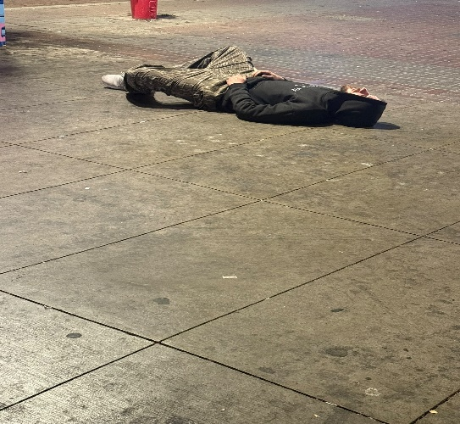
The image shows a person lying on a street or other public space, surrounded by buildings and other urban infrastructure, but not by the security and privacy of a permanent residence. This proximity to the ground provides a pictorial symbolization of vulnerability, isolation and exposure. The large surrounding space contrasts to the small-scale physical presence of the individual, with accentuation of invisibility in the public space. While it is a single moment captured in the image, it poses questions of access to housing, social support, and what constitutes a space of survival versus a shared temporary space?
The photograph is not a picture of a specific failure or weakness, but rather structural factors that can affect house security. According to DeLuca and Rosen (2022), economically disadvantaged populations' housing insecurity is linked to broader social and economic conditions, such as the housing markets, poverty, and inadequate supports. The image, then, illustrates the effect of unequal access to stable housing on people's use of public spaces as alternatives to private shelter. Homelessness is therefore not a personal problem but a social problem, characterized by unequal provision of security and vulnerability.
Homelessness is also influenced by historic and social trends of marginalization, as well as an economic imbalance. Fowle (2022) shows that racial inequities in homelessness are linked to historic housing inequities, discrimination and unequal access to resources. The image therefore is representative not only of individual suffering, but also of the differential vulnerability of specific social groups to housing insecurities within social systems. A structural approach to homelessness helps move the conversation from falls into bumps to policies, institutional and structural inequalities that affect access to safe, stable housing.
PHOTO 3 SECTION
Housing Insecurity and the Meaning of Urban Space
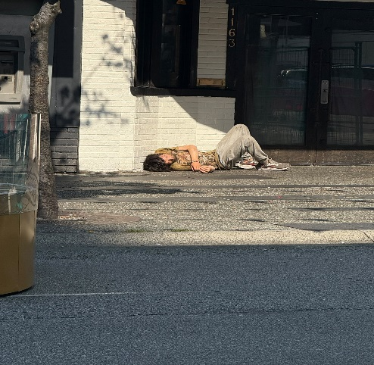
This is a photograph of a person lying next to the outside of a building, creating a strong contrast between the form of protection and the vulnerability of an individual outside. The building is a symbol of stability, ownership, privacy, and security, as the ground position indicates exposure, uncertainty, and lack of protection. The photograph depicts a typical urban scene, but it illustrates the complexity of one space being defined by multiple meanings, according to a person's social and economic status. Buildings can be place of safety and belonging to some, and place of survival to others, in the urban context. The picture thus emphasizes the unequal access to spaces people have and asks vital questions about housing access, dignity and social inclusion.
This picture shows that housing is a means of social inclusion, security, and dignity for people. According to DeLuca & Rosen (2022), the housing insecurity of low-income individuals is influenced by macroeconomic factors related to housing affordability problems, inequitable resource availability, and reduced social support networks. Housing inequality generates unequal experiences of urban life as is shown by the contrast between the protected building and the person outside. People living without a fixed address may encounter challenges accessing work, health care, social interactions, and community involvement. Thus, the image criticizes a single view of homelessness and instead addresses the power play of social institutions in securing security, stability, and belonging in a city.
PHOTO 4 SECTION
Urban Development and Unequal Displacement
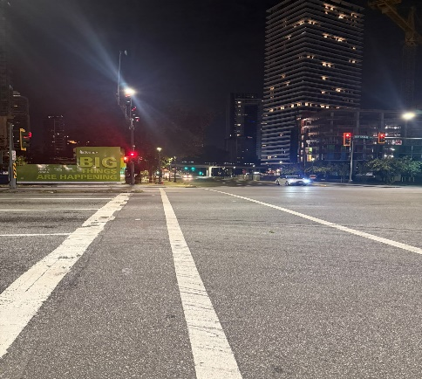
The overall image depicts a contemporary urban landscape with built-up structures, orderly arrangement, and a bustling city intersection. The image captures the tangible aspects of urban expansion, such as investment, buildings, and the transformation of urban landscapes. The image on the first viewing might display economic development and progress, but urban change can also show up inequitable social outcomes. The presence of sophisticated infrastructure doesn't guarantee the same benefit to all residents. The image evokes questions connected to who has access to these growing valued spaces and who may be barred from being there as neighborhoods evolve. Hence, the picture shows the interconnection of urban development, economic growth and social inequality.
Urban development is sometimes marketed as a sign of progress, but it can also lead to the displacement and exclusion of less well-off groups, increases the difficulty for certain groups to access neighborhoods. Hwang and Ding (2020) provide evidence of the relationship between gentrification processes and unequal patterns of displacement and racial stratification affirming that gentrification does not impact all equally. This image emphasizes a phenomenon of exclusion from urban transformation, who lose out and who wins out as costs grow and social circumstances evolve. In social justice terms, cities must not only be judged by their economic or built production but also on their ability to allow citizens to continue to have meaningful access, belonging, and participation in changing communities.
PHOTO 5 SECTION
Public Space and Social Belonging
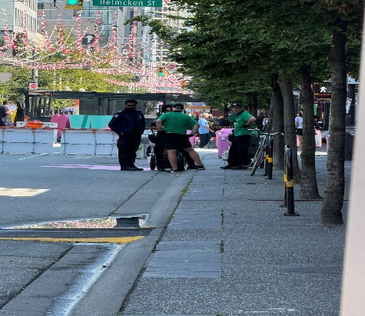
The image shows a group of people in a public space, highlighting the importance of communal areas for social interaction and engagement. The public space is not defined by ownership nor access, but is open to people to connect, communicate, and partake in collective life. Multiple individuals are seen interacting in the same space, indicating a level of social engagement and connectedness within the surrounding community. The image, however, also invites reflection on how people may have different ways of experiencing public spaces. While public areas are intended to be shared spaces, social identity, economic status, and sense of safety can affect individual experiences of being welcomed, represented and included.
The public space is important for social cohesion as it allows people to interact, participate and form communities. Aelbrecht and Stevens (2019) state that the design and structure of public spaces impact the sense of connection and belonging that people can feel to a community. These settings can also reinforce exclusion when some groups are excluded from or do not feel welcome in those groups. This photograph therefore exemplifies the nature of public spaces as they can both foster a sense of connectedness and social belonging, or highlight different inequalities in society. In terms of social justice, true inclusion in a public space would involve thinking about who's there, what their needs are, and what their experiences are. Use of and engagement with public places are important components of social belonging.
PHOTO 6 SECTION
Safety, Mobility, and Unequal Experiences of Space
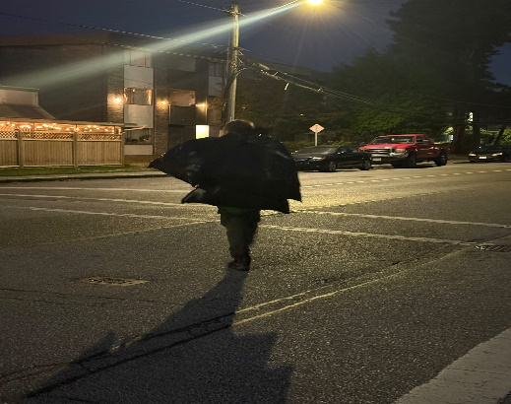
The image depicts a person walking through a street at night, surrounded by a cityscape with buildings and streetlights. The image illustrates the ways in which moving in public spaces can be accompanied by a variety of comfort, safety and vulnerability in an informally expected way. The physical nature of a street might be neutral, but it can be a subject of different realities for every social identity and individual experience. The perception of public space is affected by light and visibility, environmental design and people. The person in the photo stands alone, highlighting the relationship between people and their environment, and the possibility that not everyone is equally free and confident when experiencing shared spaces, especially at night.
This picture illustrates how public spaces are not enjoyed by the people all equally. Navarrete-Hernandez et al. (2021) describe how gender differences and urban design aspects such as visibility, lighting, and environmental conditions all affect perceptions of safety in public areas. As such, safety is not only an individual problem, but also a social problem related to the development and management of space. Mobility is an important aspect of social justice, since it impacts our access to education, employment, recreation and community participation. This image is used to show that making environments equitable is about recognizing the distinct vulnerabilities of people and designing spaces so that everyone can engage in public life with increased security.
Conclusion
The six photographs show that social injustice is not always apparent, but can be present in everyday surroundings. This essay discusses the social structures that affect the accessibility, housing, urban development, participation in public spaces and safety of everyday spaces. The pictures reflect overlapping patterns of inequity, such as unequal access to nature areas, homelessness, housing precarity, effects of urban development on housing, sense of belonging, and disparities of safety in public places. The results show that space is not neutral, but shaped by social decisions and policies and economic systems that affect people's opportunities and experiences. Photography of life reveals social injustice as more than just a personal experience; it is created in the social conditions surrounding access, belonging and opportunity. To comprehend the concept of justice, it is essential to focus on the surroundings in which people live and the systems that influence them.

References
Aelbrecht, P., & Stevens, Q. (Eds.). (2019). Public space design and social cohesion: An international comparison. Routledge. https://books.google.com/books?hl=en&lr=&id=LeGEDwAAQBAJ&oi=fnd&pg=PA1950&dq=public+space+belonging+social+inclusion+inequality&ots=NfNongCLD3&sig=X09WoqZEqTBK3boo5v-R3yUDPMk
Chen, Y., Yue, W., & La Rosa, D. (2020). Which communities have better accessibility to green space? An investigation into environmental inequality using big data. Landscape and Urban Planning, 204, 103919. https://www.sciencedirect.com/science/article/pii/S0169204619316780
DeLuca, S., & Rosen, E. (2022). Housing insecurity among the poor today. Annual Review of Sociology, 48, 343-371. https://www.annualreviews.org/content/journals/10.1146/annurev-soc-090921-040646
Fowle, M. Z. (2022). Racialized homelessness: A review of historical and contemporary causes of racial disparities in homelessness. Housing Policy Debate, 32(6), 940-967. https://www.tandfonline.com/doi/abs/10.1080/10511482.2022.2026995
Hwang, J., & Ding, L. (2020). Unequal displacement: Gentrification, racial stratification, and residential destinations in Philadelphia. American journal of sociology, 126(2), 354-406. https://www.journals.uchicago.edu/doi/abs/10.1086/711015
Navarrete-Hernandez, P., Vetro, A., & Concha, P. (2021). Building safer public spaces: Exploring gender difference in the perception of safety in public space through urban design interventions. Landscape and urban planning, 214, 104180. https://www.sciencedirect.com/science/article/pii/S0169204621001432

